Dustin O’Brien

COSC – 320 01 Lab 4 2/28/23

Lab report:

It took roughly 4 and a half hours to complete this assignment most of it went to trying to understand how various functions worked I had problems with what variable to use and if a function should be called as a class or separate from the tree in the parameters

Lab 04



Q 1.

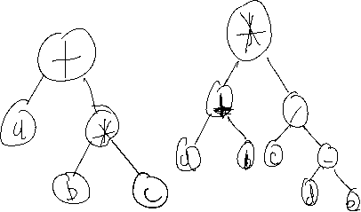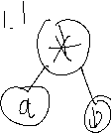

Q.2

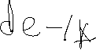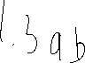

If you imagine each letter variable as a single term on it’s own and then

Use operations to merge terms the post-order equations will reform into the infix versions and do the preorder backward as in the last letter to first and do the same idea the preorder will turn into infix equation.

Output:

Enter Expression (a+b)/c

Output:

Prefix form / + a b c

Postfix form a b + c /

/

+ c

a b